GraphLang Tunnel problem

Tunnels at picture below are not returned as children of loop, because they were added in code using:
loop.add(….)
instead:
canvas.add()

so they are part of loop but not returned in list of figures from canvas when used:
canvas.getFiugres()

That’s reason why when working with wires or something I need to check also loops for tunnels.

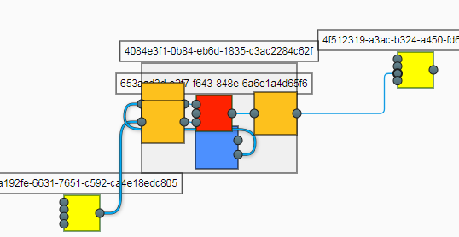Figure 1: Example diagram

